[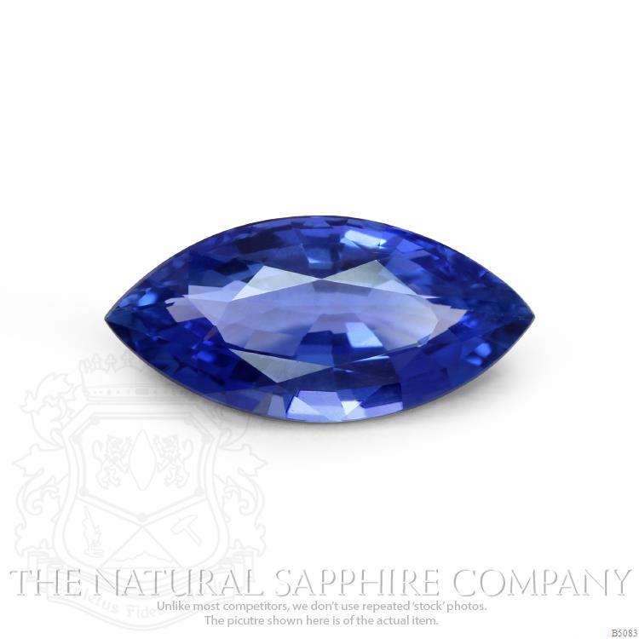](https://www.google.com/url?sa=i&url=https%3A%2F%2Fwww.thenaturalsapphirecompany.com%2Fblog%2Flady-gaga-heart-shape-engagement-ring&psig=AOvVaw3N7R5QFtqBrVXCZ-FfP4fc&ust=1584042589170000&source=images&cd=vfe&ved=0CAIQjRxqFwoTCKit1O2Yk-gCFQAAAAAdAAAAABAD)[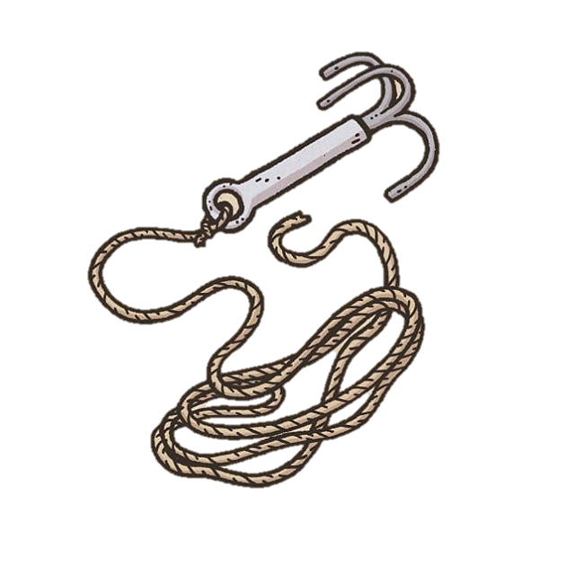](https://www.google.com/url?sa=i&url=https%3A%2F%2Fwww.pinterest.cl%2Fpin%2F358317714102652767%2F&psig=AOvVaw1IyrsbpmgB0lE07R0QDOsW&ust=1584042102605000&source=images&cd=vfe&ved=0CAIQjRxqFwoTCIjdq-qWk-gCFQAAAAAdAAAAABAK)[](https://www.google.com/url?sa=i&url=https%3A%2F%2Fwww.therpf.com%2Fforums%2Fthreads%2Fdarth-vader-melted-helmet-kit-upgrade.267356%2Fpage-2&psig=AOvVaw2C_0p4MoIaazfy_Rt5wh0H&ust=1584041428985000&source=images&cd=vfe&ved=0CAIQjRxqFwoTCIDPy6uUk-gCFQAAAAAdAAAAABAD)[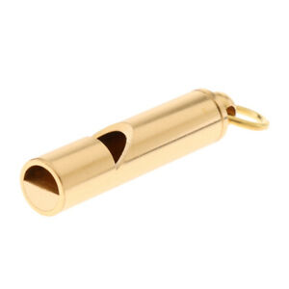](https://www.google.com/url?sa=i&url=https%3A%2F%2Fwww.ebay.com%2Fitm%2FProfessional-Dog-Training-Whistle-Train-Your-Dog-to-Stop-Barking-Golden-%2F352645467955&psig=AOvVaw2sjeLHFb8HiU-lutkkQb4y&ust=1584040750768000&source=images&cd=vfe&ved=0CAIQjRxqFwoTCMij6_GRk-gCFQAAAAAdAAAAABAE)[](https://www.google.com/url?sa=i&url=https%3A%2F%2Fwww.dandwiki.com%2Fwiki%2FRing_of_Bravado_(5e_Equipment)&psig=AOvVaw0Ijria58dyxLveRPDdxeKA&ust=1584040295434000&source=images&cd=vfe&ved=0CAIQjRxqFwoTCLiku5qQk-gCFQAAAAAdAAAAABAL)[](https://www.google.com/url?sa=i&url=https%3A%2F%2Fwww.dndbeyond.com%2Fmagic-items%2Feyes-of-charming&psig=AOvVaw2Ro5hTye6Ba0W8RUDn87wm&ust=1584040056002000&source=images&cd=vfe&ved=0CAIQjRxqFwoTCMic-62Pk-gCFQAAAAAdAAAAABAZ)